Retail Sales Data Processing and Business Insights Generation

1.Project Objective

The objective of this project is to design and implement an end-to-end data engineering workflow for retail sales data.
The project focuses on data ingestion,profiling,cleaning,transformation,KPI generation,privacy protection using PII masking and business reporting using Power BI.
The solution integrates multiple retail datasets into a unified dataset and provides insights through interactive dashboards.

2.Project Structure

Folder | Contents
data | USECASE - Data Engineering.xlsx
code | 01_data_profiling.py, 02_data_cleaning.py, 03_kpi_generation.py
output | cleaned_retail_data.csv, revenue_by_category.csv, revenue_by_city.csv, revenue_by_payment_method.csv, monthly_revenue.csv
powerbi | Retail_Sales_Dashboard.pbix
documentation | Retail_Sales_Project_Report.docx, screenshots
root | README.md

3.Dataset Description
The assessment provided a single Excel workbook named USECASE - Data Engineering.xlsx.
The workbook contained three worksheets:
- product_details – Product master data containing product information, category, and standard prices.
- retail_data1 – Retail transaction records containing customer, product, quantity, pricing, payment, and city information.
- retail_data2 – Additional retail transaction records with a structure similar to retail_data1.
The retail_data1 and retail_data2 worksheets were merged to create a unified transaction dataset for analysis. The product_details worksheet was used as a reference table during data cleaning and transformation.

4.Data Profiling and Quality Assessment
A module called 1_data_profiling.py was developed to evaluate data before performing transformations.
The processes done in data profiling includes:
- Dataset structure analysis
- Column inspection
- Data type analysis
- Missing value identification
- Duplicate record detection
- Invalid quantity detection

Quality Check | Result
Total Records | 8494
Missing Prices | 809
Duplicate Records | 0
Invalid Quantities (<=0) | 93

Observations
- Missing values existed in the price column.
- Product names contained casing inconsistencies.
- Categories contained abbreviations and inconsistent naming conventions.
- Customer email addresses and phone numbers contained PII.
- Transaction dates required standardization for trend analysis.

5. Data Cleaning and Transformation
Data cleaning was implemented using 02_data_cleaning.py.

5.1 Dataset Consolidation
The retail_data1 and retail_data2 datasets were merged into a single transaction dataset using Pandas.
Purpose:
- Create a unified source for analysis
- Simplify reporting and dashboard creation

5.2 Missing Price Handling
Issue:
809 records contained missing price values.
Approach:
The transaction dataset was joined with the product_details reference table using product_id and missing prices were populated using the master product price.
Reason:
The product master dataset is the authoritative source for product pricing.
Result:
Missing prices reduced from 809 to 0.

5.3 Invalid Quantity Removal
Issue:
93 records contained quantity values less than or equal to zero.
Approach:
Invalid records were removed.
Reason:
Non-positive quantities do not represent valid sales transactions and can distort revenue calculations.
Result:
93 invalid records removed.

5.4 Date Standardization
The transaction_date field was converted into datetime format.
Additional columns created:
- Month
- Year
Purpose:
To support time-based reporting and trend analysis.

5.5 Product Name Standardization
Product names contained multiple casing variations.
Examples:
- LAPTOP
- Laptop
- laptop
These values were standardized into a single consistent format.

5.6 Category Standardization
Category values contained abbreviations and inconsistent naming.
Examples:
- ELEC → Electronics
- FURN → Furniture
- CLOTH → Clothing
- HOME → Home Appliances
Purpose:
To ensure accurate aggregation and reporting.

5.7 PII Masking
Personally Identifiable Information (PII) was protected through masking.
Examples:
- john.doe@gmail.com → jo***@gmail.com
- 9876543210 → 987****210
Purpose:
To preserve customer privacy while maintaining analytical usability.

5.8 Revenue Calculation
Two revenue metrics were generated.

Gross Revenue
Gross Revenue = Price × Quantity

Net Revenue
Net Revenue = Gross Revenue × (1 − Discount)
These metrics were used for KPI generation and dashboard reporting.

6. KPI Generation
A dedicated KPI generation module (03_kpi_generation.py) was implemented.

Core KPIs
- Total Revenue
- Total Transactions
- Total Customers
- Average Order Value (AOV)

Additional KPIs
- Revenue by Category
- Revenue by City
- Revenue by Payment Method
- Monthly Revenue Trend
- Product Revenue Analysis

7. KPI Results

KPI Summary
KPI | Value
Total Revenue | 1,239,132,235
Total Transactions | 7,914
Total Customers | 1,960
Average Order Value | 156,574,71

Revenue by Category

Category | Revenue
Electronics | 721.68M
Furniture | 257.06M
Home Appliances | 242.33M
Clothing | 18.06M

Revenue by City
City | Revenue
Chennai | 259.25M
Delhi | 256.87M
Hyderabad | 248.81M
Mumbai | 247.07M
Banglore | 227.13M

Top Product
Laptop generated the highest revenue among all products.

8. Dashboard Development
A Power BI dashboard was developed to provide interactive business insights.

Dashboard Pages

Executive Dashboard
Included:
- Total Revenue
- Total Transactions
- Total Customers
- Average Order Value
- Revenue by Category
- Revenue by City
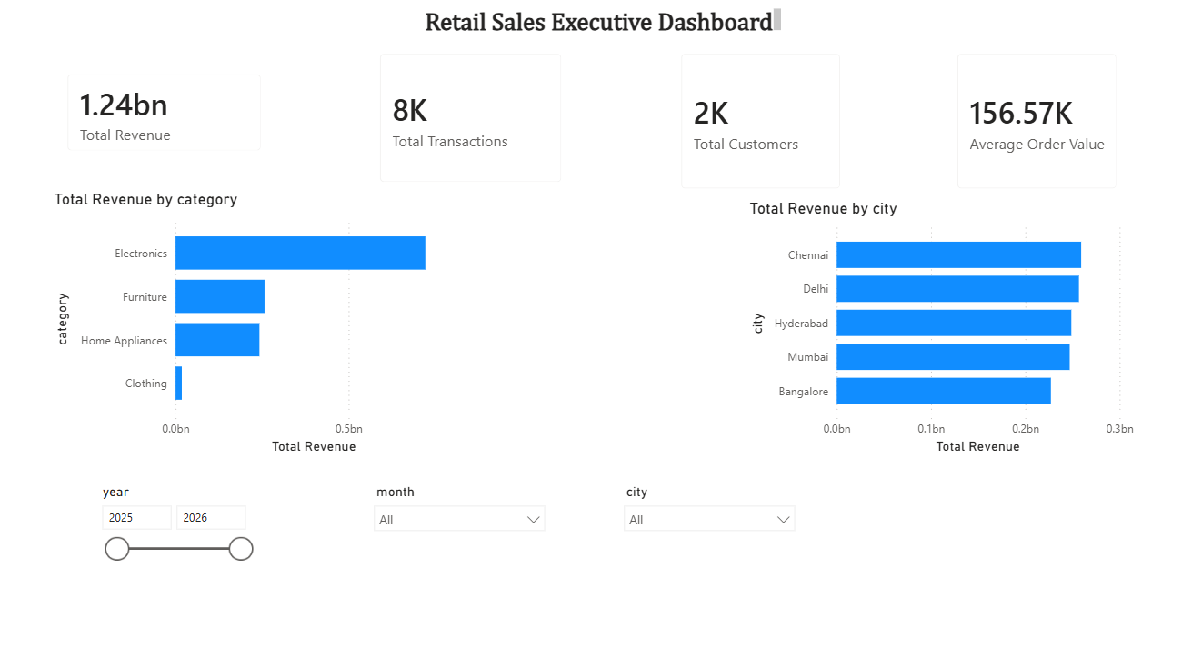

Product Performance
Included:
- Revenue by Product
- Category Contribution
- Product Ranking Table
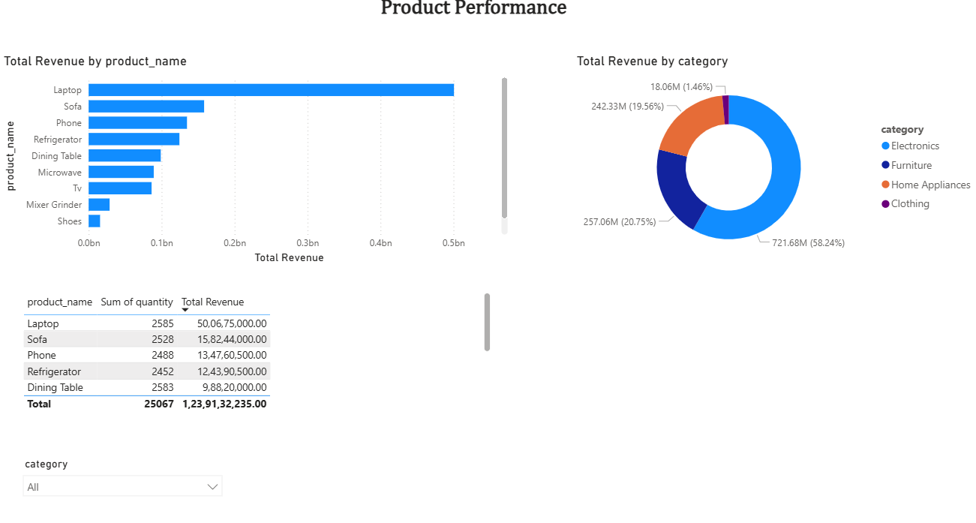

Regional Insights
Included:
- Revenue by City
- Revenue by Payment Method
- Regional Revenue Analysis
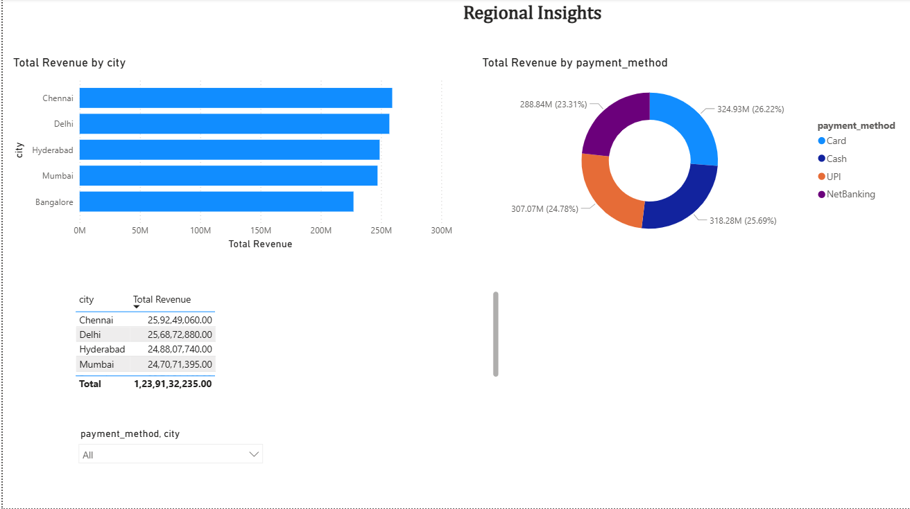

Revenue Trends
Included:
- Monthly Revenue Trend
- Monthly Transaction Trend

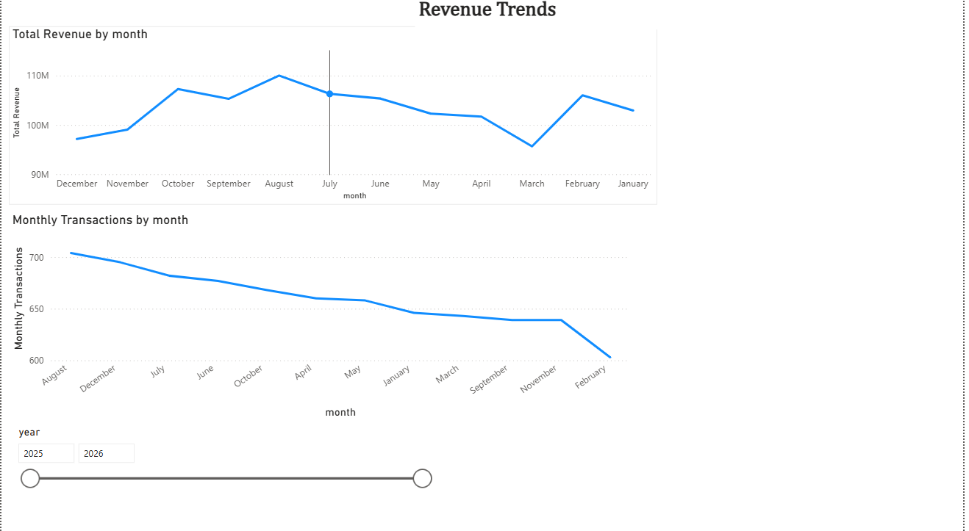

9.Architecture Diagram
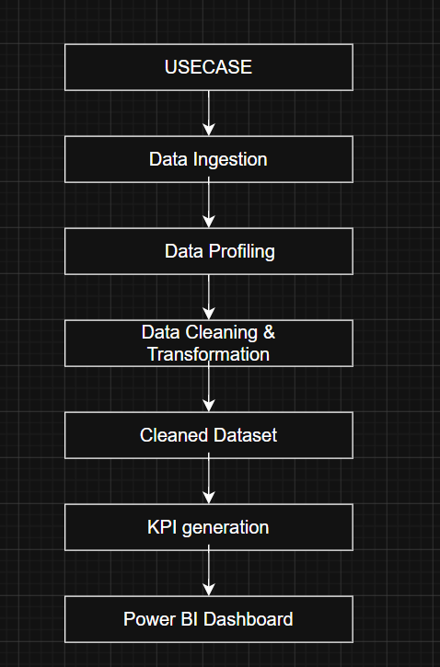

10. Key Business Insights
- Electronics generated the highest revenue among all categories.
- Laptop was the highest revenue-generating product.
- Chennai generated the highest city-level revenue.
- Revenue distribution across major cities was relatively balanced.
- Clothing contributed the lowest share of total revenue.
- Multiple product and category naming inconsistencies were successfully standardized, improving reporting accuracy.

11. Assumptions
- Missing prices were populated using the product master table.
- Records with quantity less than or equal to zero were considered invalid and removed.
- Product and category standardization was necessary to ensure accurate aggregation.
- PII masking was applied for analytical and reporting purposes.
- The product_details dataset was treated as the authoritative source of product pricing.

12. Technologies Used
- Python
- Pandas
- Power BI Desktop
- VS Code

13. Conclusion
This project successfully implemented an end-to-end retail sales data engineering workflow. The solution included data ingestion, profiling, quality assessment, data cleaning, standardization, PII masking, KPI generation, and dashboard-based business reporting.
The final outcome provides a clean analytical dataset and interactive dashboards that enable business users to monitor revenue performance, product trends, customer activity, and regional sales insights.

